# Skin Color Detection

## RGB

The RGB method is based on the algorithm developed by S. Kolkur et el at 2016. Using this method, pixels that contain skin color has been filtered out, and marked as pure black (assigned 0 to those pixels, and 1 to others).

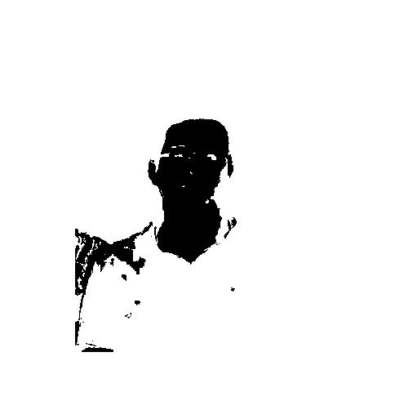

Figure 1: RGB

## Normalized RGB

The Normalized RGB method is also based on the algorithm developed by S. Kolkur et el at 2016. But before filtering by this algorithm, all pixels have been taken average r g b value. Pixels contain skin color has been filtered out and marked as pure black (assigned 0 to those pixels, and 1 to others).

# 

Figure 2: Normalized rbg

## HSV

Using MATLAB build-in function HSV

# 

Figure 3: MATLAB built-in function HSV

# Image halftoning

There are some issue while I trying to load the given David image on Canvas, So I download a David picture from Google, Shown as Figure 4.

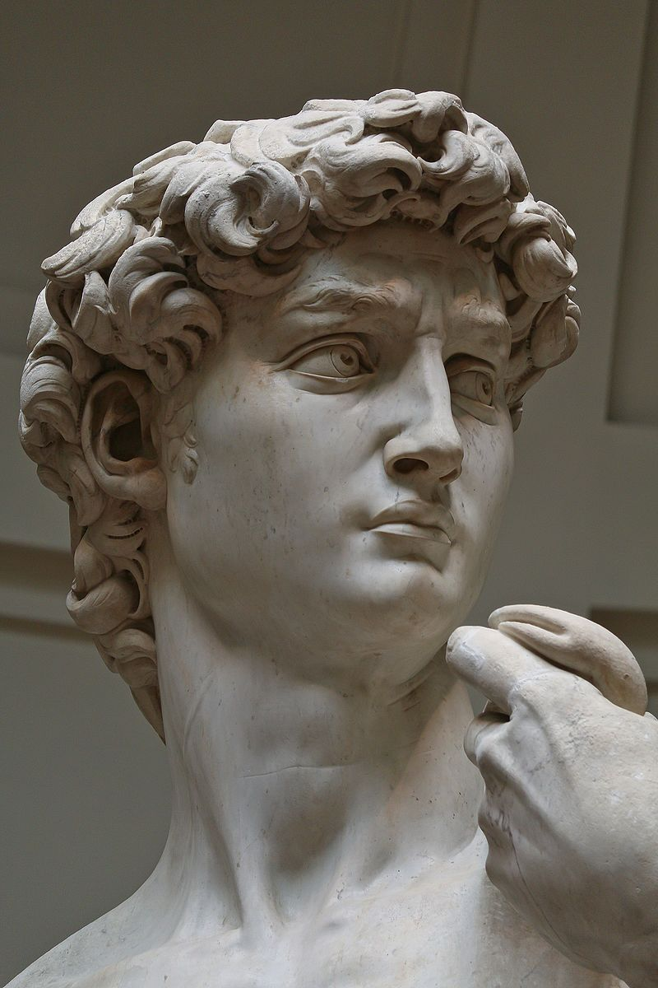

Figure 4: David

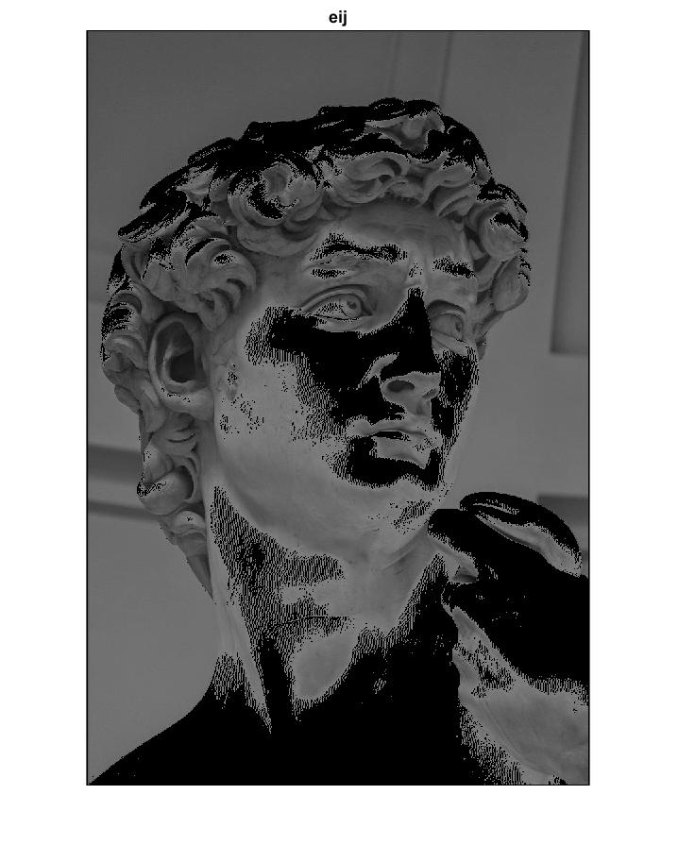

Figure 5: eij

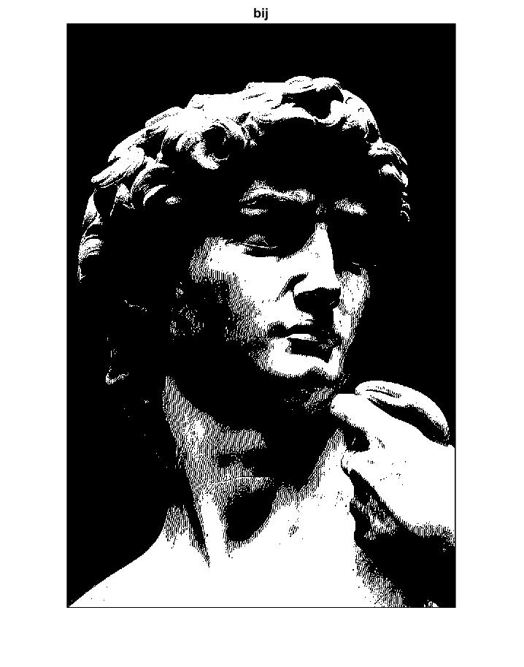

Figure 6: Center detection

# Sources:

[1] David (Michelangelo). (2019, April 08). Retrieved from <https://en.wikipedia.org/wiki/David_(Michelangelo)>